Name Mohd Monish
Registration No. 2021CA063

PROGRAM 1

/*1. WAP to print information about yourself.*/

#include<stdio.h>
int main(){
printf("Hii, my name is Mohd Monish\ni'm first year student at MNNIT Allahabad");
printf("\nBefore this i have completed my graduation from University of Delhi\n");
}

OUTPUT 1

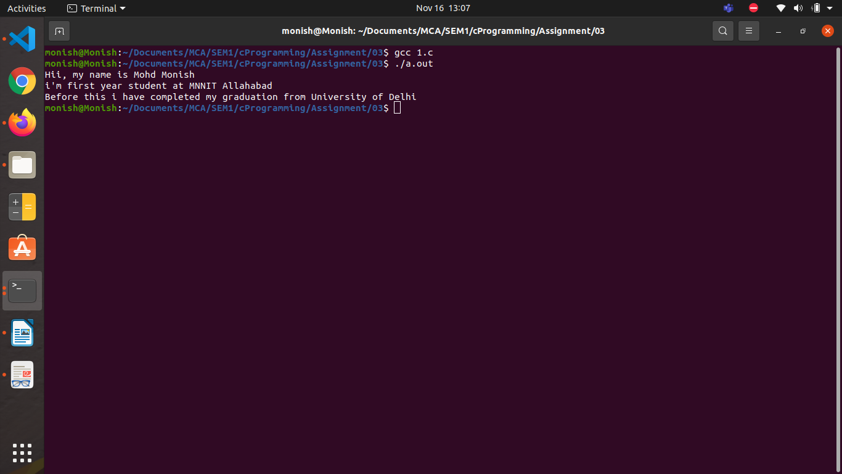

Name Mohd Monish
Registration No. 2021CA063

PROGRAM 2
/*2. Write a program in C that takes input through keyboard for two integer variables and
calculate their sum, difference, multiplication & division.
*/
#include<stdio.h>
#include<stdlib.h>
int main(){
float a,b,result=0;
int choice;
printf("\nPlease Enter the First Element : ");
scanf("%f",&a);
printf("\nPlease Enter the Second Element : ");
scanf("%f",&b);
//value of a and b are provide by user
while(1){
//always true so it run againg and again
printf("\n1.Addition \n2.Substraction\n3.Multiplication \n4.Divison\n5.Exit \n\nPlease enter your choice : ");
//provide a menu bar of operations
scanf("%d",&choice);
//when user enter their operation type
switch(choice){
case 1 : {printf("\nAddition Operation Selected\n");
result=a+b;
break;}
case 2 :{printf("\nSubstraction Operation Selected\n");
result=a-b;
break;}
case 3 : {printf("\nMultiplication Operation Selected\n");
result=a*b;
break;}
case 4 :{printf("\nDivison Operation Selected\n");
result=a/b;
break;}
case 5:exit(0);//exit case
default :{ printf("\n\n Ivalid Choice !!!!!!!!\n\n");
break;}
//if user enter any other number that will not given in options it will be wrong choice
}
printf("Final Result = %f \n\n\n",result);
//final result will be display here
}
return 0;
}
OUTPUT 1

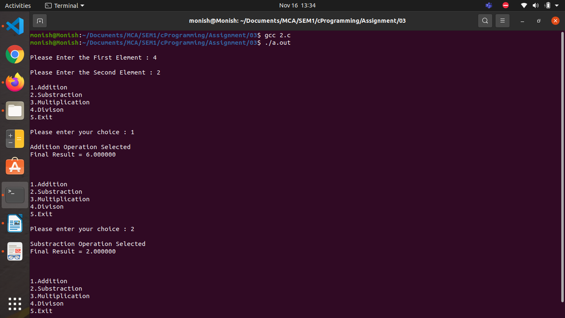

OUTPUT 2

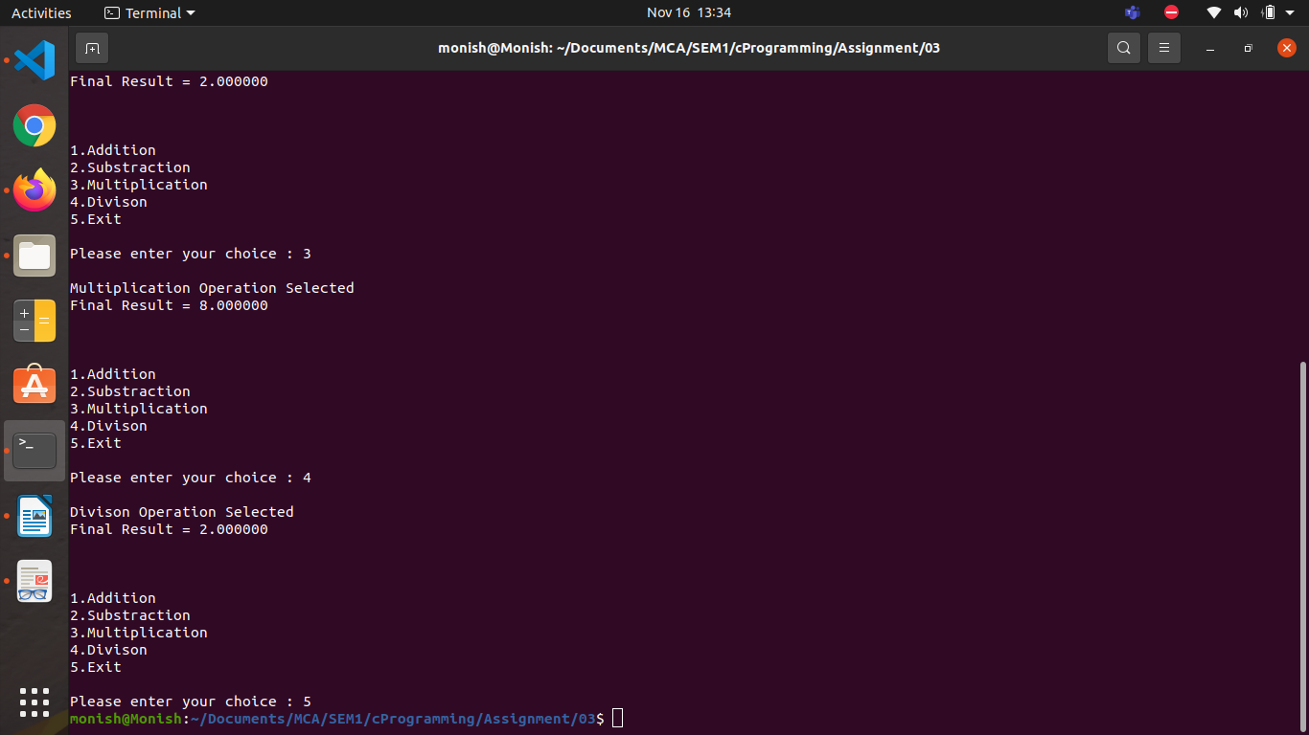

Name Mohd Monish
Registration No. 2021CA063

PROGRAM 3
/*3. Rajesh’s basic salary is input through the keyboard. His dearness allowance is 40% of basic
salary, and house rent allowance is 20% of basic salary. Write a program in C to calculate
his gross salary.*/

#include<stdio.h>
int main(){
int t;
float basicSalary,grosSgalary,HRA,DA;
printf("\nPlease inter Rajesh’s basic salary : ");
//taking input Rajesh’s basic salary
scanf("%f",&basicSalary);
//read and store in varible
HRA=basicSalary*.20;
//calculate HRA
DA=basicSalary*.40;
//calculate DA
grosSgalary=basicSalary+HRA+DA;
//calculating grosSgalary
printf("\nRajesh’s Gross Salary : %f\n\n",grosSgalary);
//final output here
return 0;
}

OUTPUT

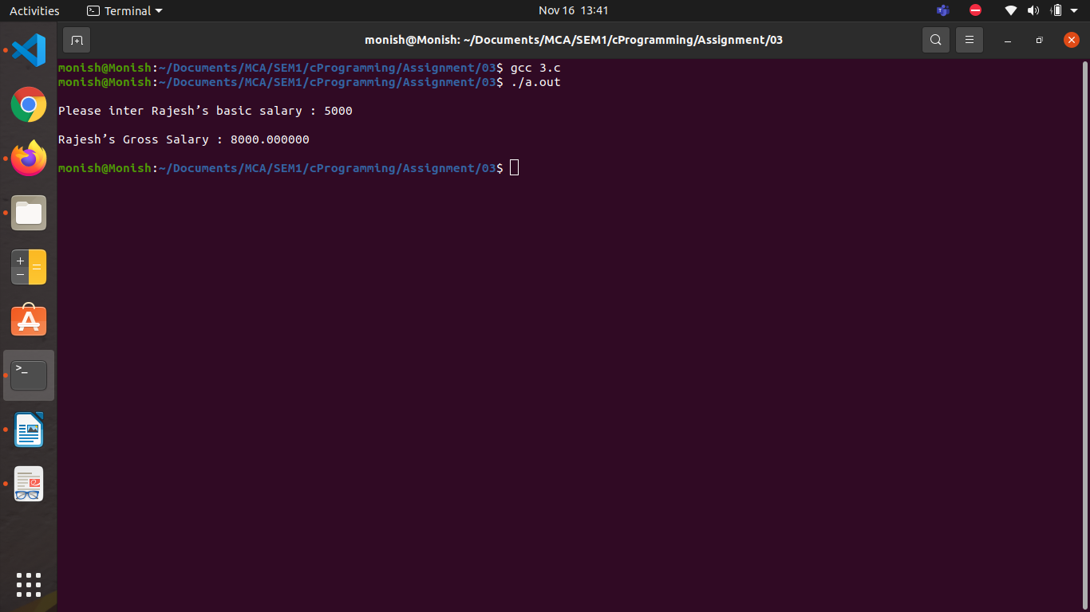

Name Mohd Monish
Registration No. 2021CA063

PROGRAM 4
/*4. The distance between two cities (in Km) is input through the keyboard. Write a program
to convert and print this distance in meters, feet, inches and centimeters. */
#include<stdio.h>
int main(){
float distance;
printf("\nPlease inter distance between in Kilometers : ");
//taking input from user distance in kilometers
scanf("%f",&distance);
//store value in distance variable
printf("\nDistance in meters :%f",distance*1000);
//convert distance in meter
printf("\nDistance in feet :%f",distance*3280.84);
//convert distance in feet
printf("\nDistance in inches : %f",distance*39370.1);
//convert distance in inches
printf("\nDistance in centimeters :%f\n",distance*100000);
//convert distance in centimeters

}
OUTPUT
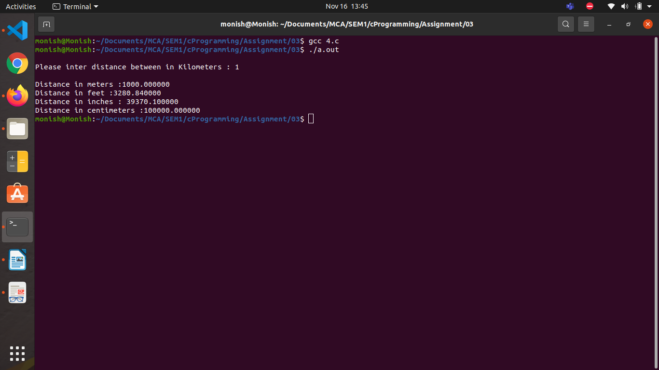

Name Mohd Monish
Registration No. 2021CA063

PROGRAM 5
/*5. If the marks obtained by a student in five different subjects are input through the keyboard, find
out the aggregate marks and percentage marks obtained by the student. Assume maximum
marks in each subject=100.*/
#include<stdio.h>
int main(){
float marks=0,total_marks=0;
for (int i = 0; i < 5; i++)
{ printf("\nPlease inter the subject marks of %d : ",i+1);
//taking input of 5 subjects marks one by one
scanf("%f",&marks);
if (marks>100|| marks<0){
/*if user enter invalid marks then if condition will be true and error message give
and user need to enter the correct marks */
printf("\nnvalid Marks!\nPlease inter marks greater than or equals to zero and less than or equals to 100!\n");
i--;
marks=0;
continue; }
total_marks=total_marks+marks;}
printf("\nAggregate Marks = %f",total_marks);
printf("\nPercentage Marks = %f\n\n",total_marks/5);
return 0;
}
OUTPUT

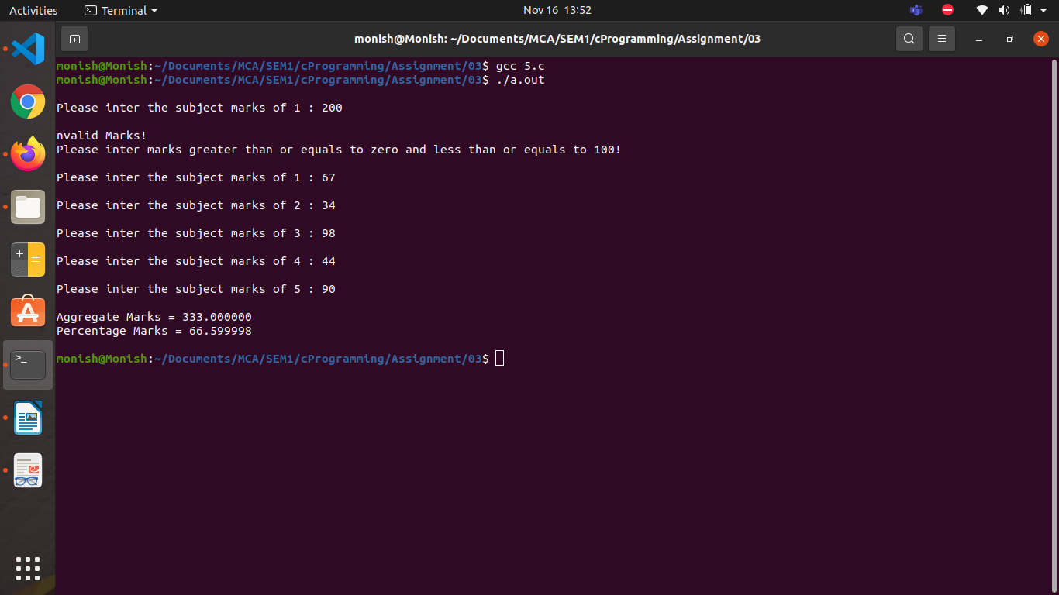

Name Mohd Monish
Registration No. 2021CA063

PROGRAM 6
/*6. Temperature of a city in Fahrenheit degrees is input through the keyboard. Write a program
to convert this temperature into Centigrade degrees.*/

#include<stdio.h>
void main()
{
float celsius,fahrenheit;
printf("\nEnter temperature in Fahrenheit:");
//taking temperature input from user in Fahrenheit
scanf("%f",&fahrenheit);
//storing value
celsius=(fahrenheit - 32)*5/9;
//converting in celsius
printf("%.4f Celsius = %.4f Fahrenheit \n", celsius, fahrenheit);
}

OUTPUT

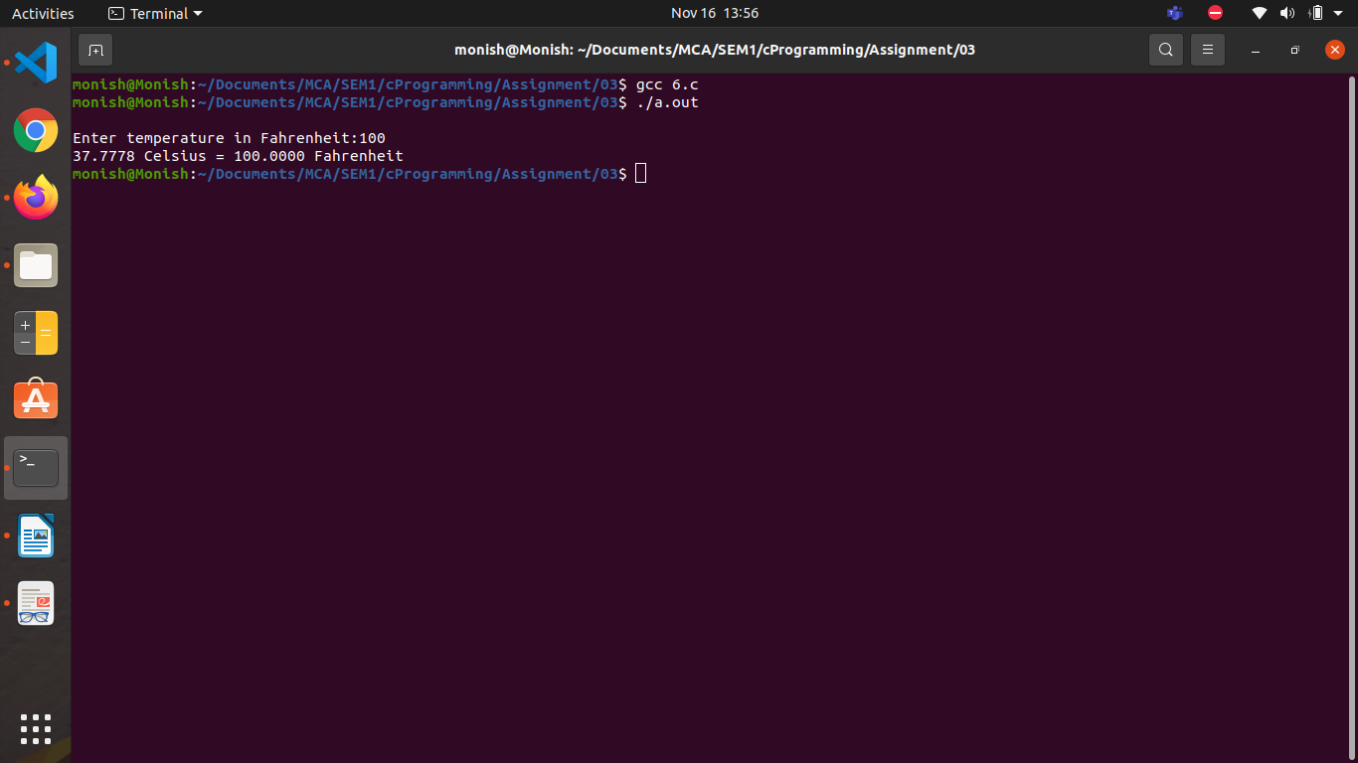

Name Mohd Monish
Registration No. 2021CA063

PROGRAM 7
/*7. The length and breadth of a rectangle and radius of a circle are input through the keyboard. Write
a program in C to calculate the area & perimeter of the rectangle, and the area & circumference
of the circle.*/
#include<stdio.h>
int main(){
printf("\n This is program to calculate area and parameter of rectangle and circle !\n");
float hight,width,radius;
printf("\nPlease enter Hight of Rectangle : ");
scanf("%f",&hight);
//taking input height of rectange
printf("\nPlease enter Width of Rectangle : ");
scanf("%f",&width);
//taking input Radius of rectange
printf("\nPlease enter Radius of Circle : ");
scanf("%f",&radius);
//taking input Radius of rectange
printf("\nArea of rectangle is %f and Parameter of rectangle is : %f ",hight*width,2*(hight+width));
//calculating area and parameter of rectangle i.e. hight*width and 2(hight+width)
printf("\nArea of Circle is %f and Parameter of Circle is : %f ",3.14*radius*radius,2*3.14*radius);
//calculating area and parameter of Circle
printf("\n\n");
}
OUTPUT
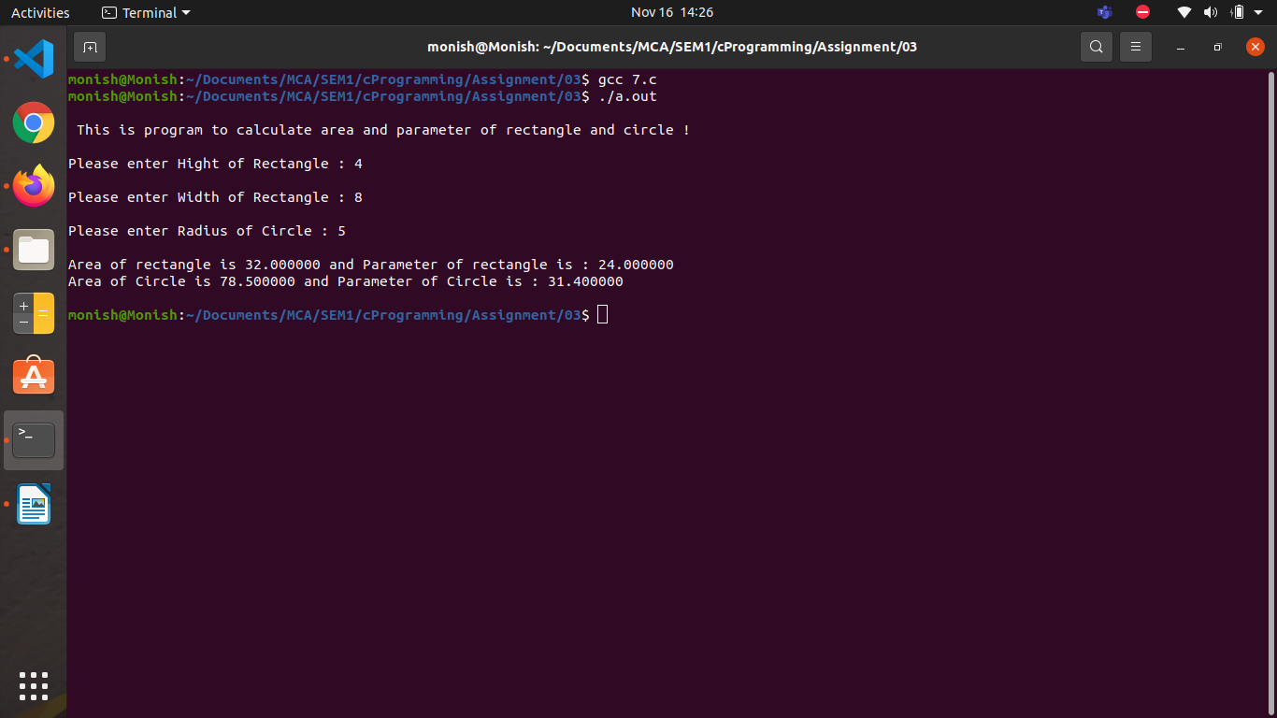
Name Mohd Monish
Registration No. 2021CA063

PROGRAM 8
/*8. Two numbers are input through the keyboard into two locations A and B. Write a program in C
to interchange the contents of A and B. */

#include<stdio.h>
int main(){
int a,b,temp;
printf("\nPlease Enter Integer Value of A : ");
scanf("%d",&a);
printf("\nPlease Enter Integer Value of B : ");
scanf("%d",&b);
printf("\nValue Entered By you A = %d & B = %d \n",a,b);
temp=a;
//storing vlaue of a in temp variable
a=b;
//transfring value of a in b
b=temp;
//storing value of temp in b
printf("\nAfter Swaping value of A = %d & B = %d \n",a,b);
//display the result afer swaping
return 0;
}

OUTPUT

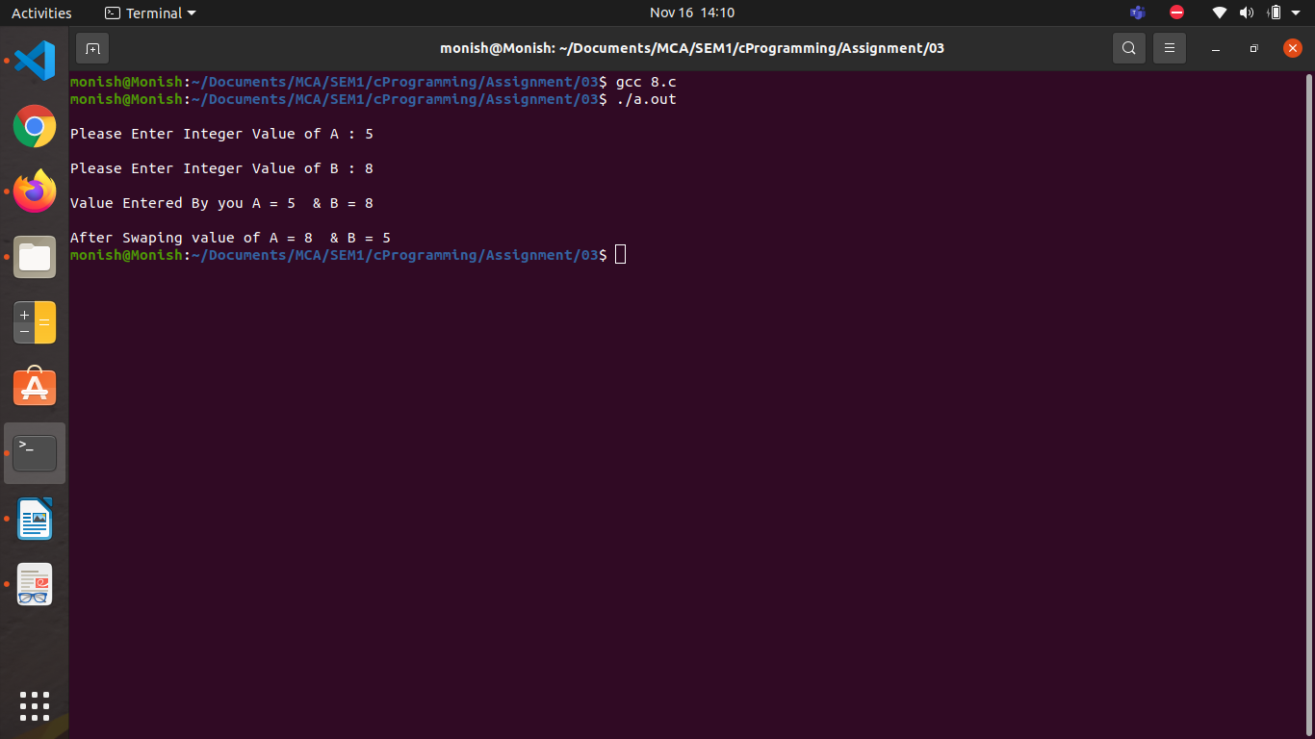

Name Mohd Monish
Registration No. 2021CA063

PROGRAM 9
//9. WAP to swap two variables without using 3 rd variable.
#include<stdio.h>
int main(){
int a,b;
printf("\nPlease Enter Integer Value of A : ");
scanf("%d",&a);
printf("\nPlease Enter Integer Value of B : ");
scanf("%d",&b);
printf("\nValue Entered By you A = %d & B = %d \n",a,b);
a=a+b-(b=a);
printf("\nAfter Swaping value of A = %d & B = %d \n",a,b);

}

OUTPUT

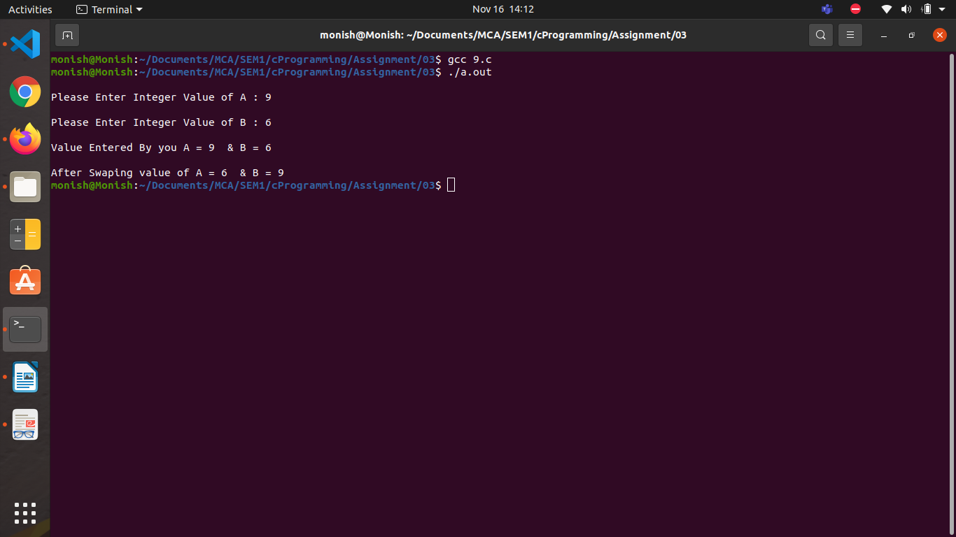

Name Mohd Monish
Registration No. 2021CA063

PROGRAM 10
/*10. WAP to find the area of a triangle given base and height as input from key board.*/
#include<stdio.h>
int main(){
printf("\n This is program to calculate area of triangle !\n");
float hight,base;
printf("\nPlease enter Height of Triangle : ");
scanf("%f",&hight);
//taking input height base of Triangle
printf("\nPlease enter base of Triangle : ");
scanf("%f",&base);
// taking input base of Triangle
printf("\nArea of Triangle is : %f \n",.5*hight*base);
//claculating area of triangle
}

OUTPUT

